Insights from Cardekho Data

# EDA - Cardekho

Note - Consider opening this file in google doc for better visibility

## Which 15 model we have the most :

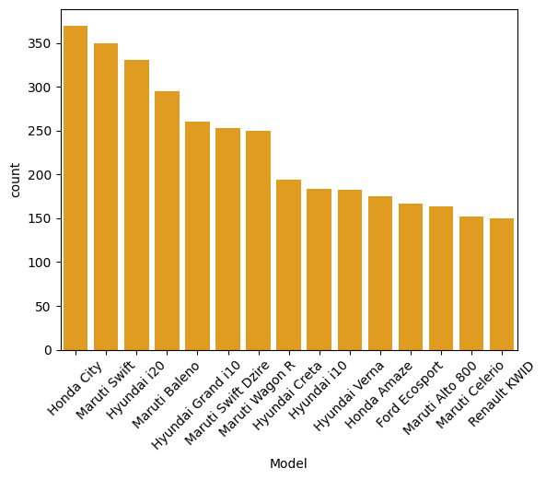

## 

## Which 15 Variant we have the most :

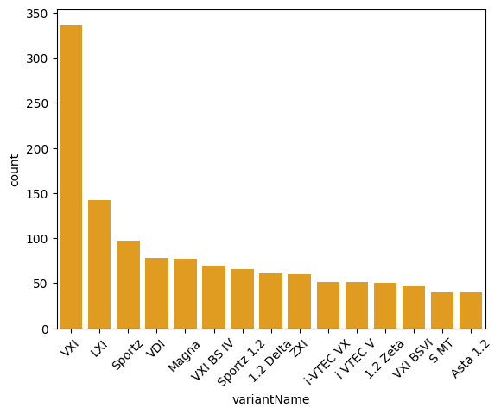

That too VXI and LXI variant are dominating the most need to find the market trend and verify this models are in trend if not need to do some other plan

## In which cities we have the most number of cars:

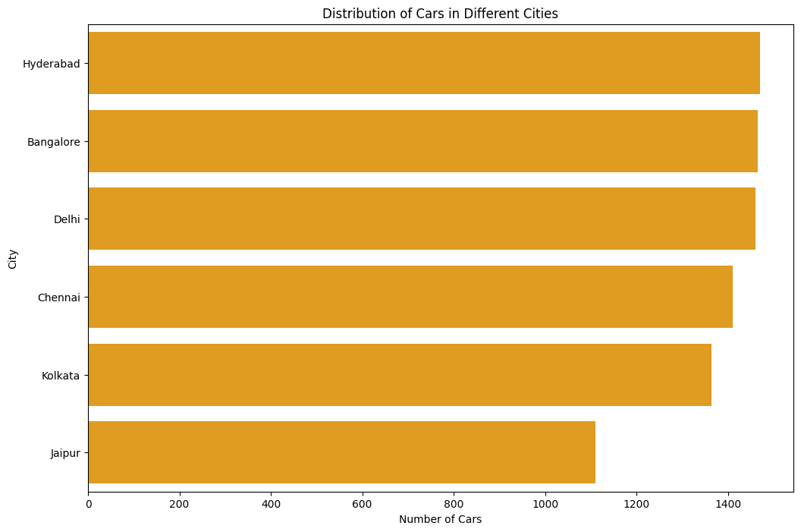

In Hyderabad we have the most cars. We need to do a market and demand analysis city wise and decide whether we are satisfying the requirement or we are focusing in the wrong area.

## 

## 

## 

## What kind of Fuel type we have the most:

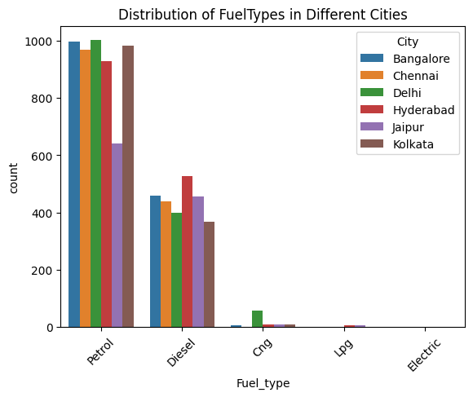

We have the Petrol and Diesel type cars the most. I have found some cars that have a previous owner. If possible we need to have the most number of first hand electric vehicles since that’s the future.

## What type of transmission type do we have the most

## 

## 

We have the manual cars the most since the Automatic cars have a high profit. After doing a market analysis we can increase the Automatic Transmission Type.

## Number of model Vs Manufactured Year:

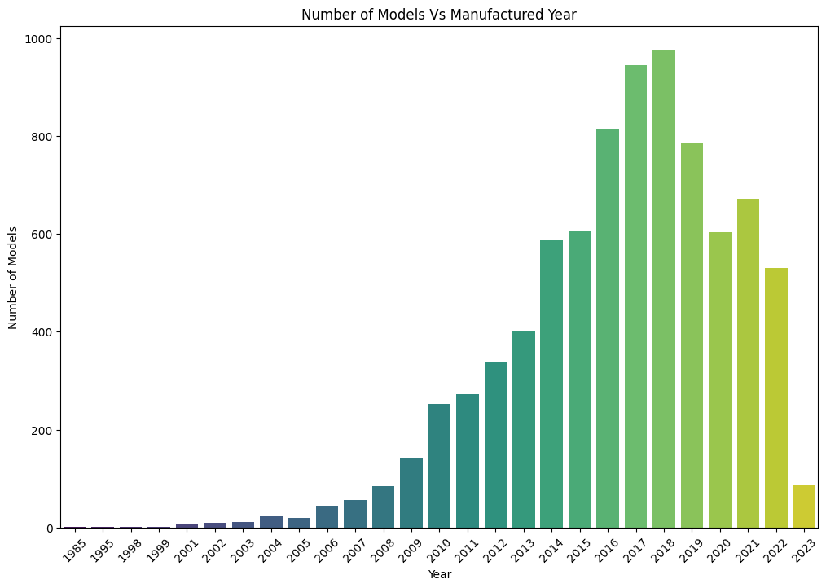

Most of the people don’t prefer the 25 or 30 year old cars until or unless it has a brand value so filter the car based on that and decide what we need to do based on the car condition.

## 

## 

## Interior system is cars:

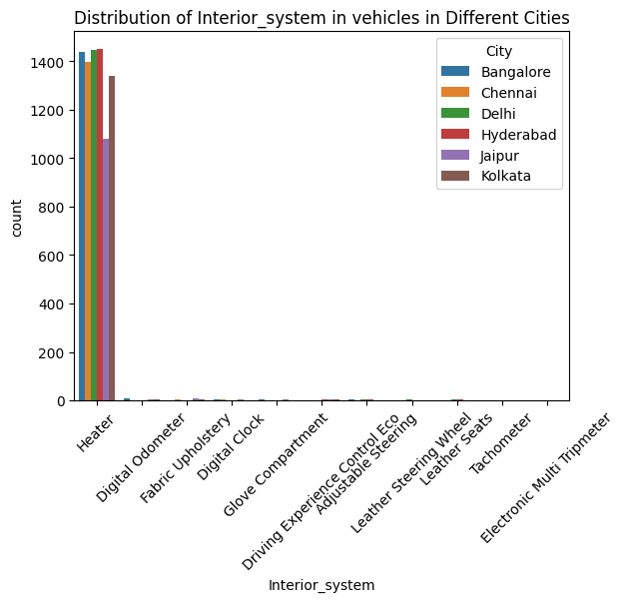

Most of the cars have a heater system which is not mostly used in countries like India.Need to decide whether it is needed or not.

## Safety Features in our vehicles :

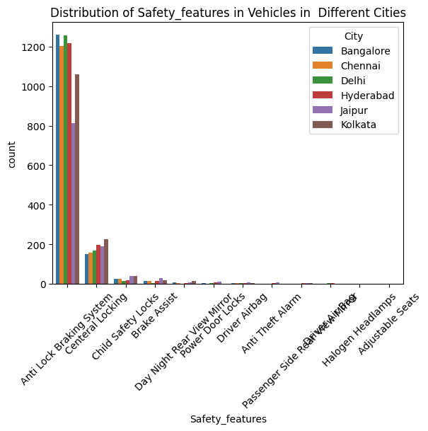

We have Anti lock braking, central Locking,Child safety Locks Brake Assist the most but we don’t have a Driver Airbag needed to work on it.

## Which car have more life:

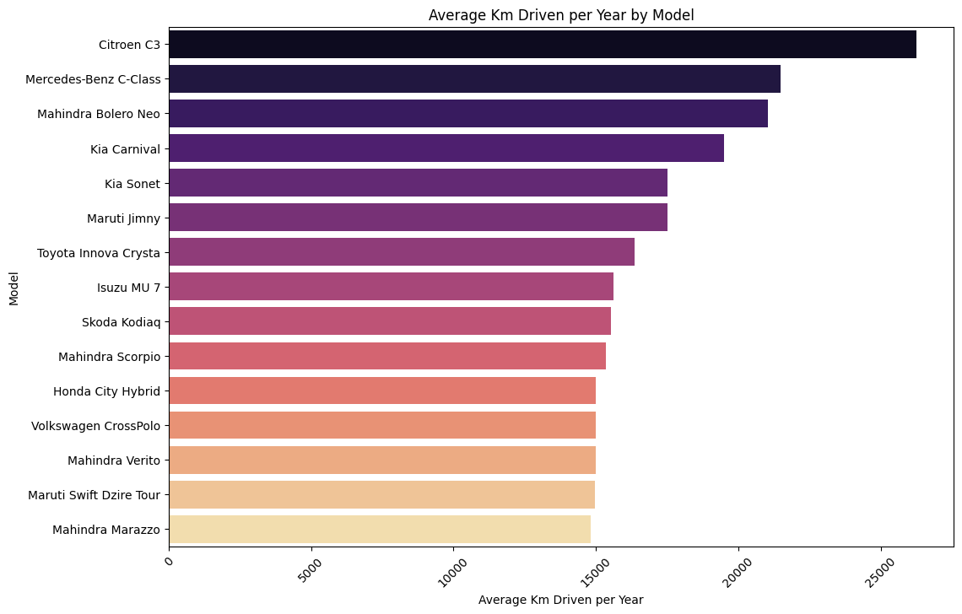

These are the cars performing exceptionally well and these have a longer Life.

Effect of Car Age on Price

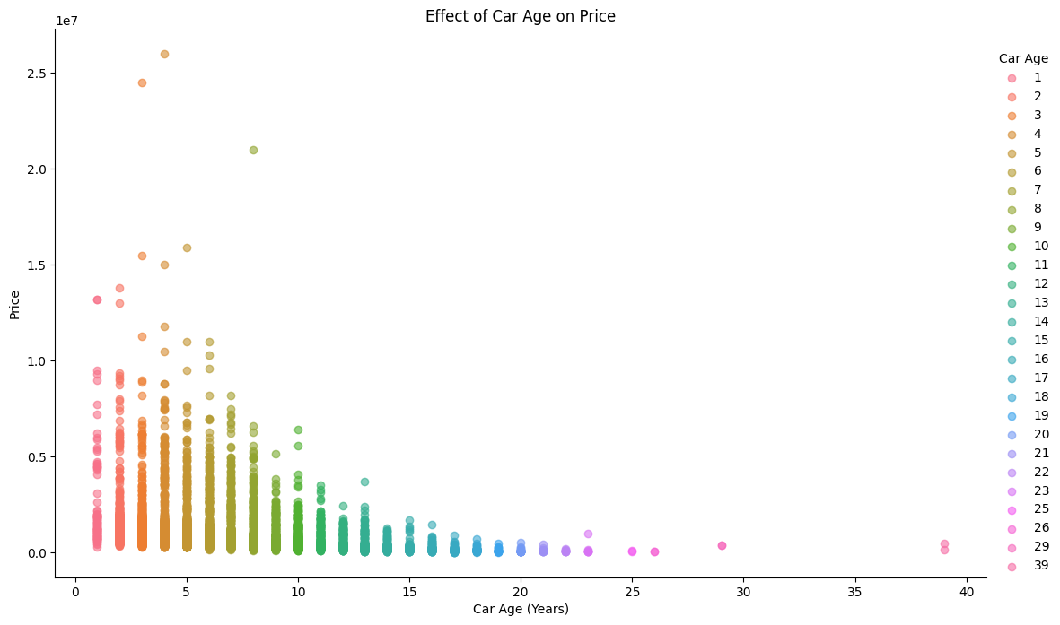

As the car Age increases the price is decreasing no matter what the Model is so we have some cars which have an age higher than 20 need to sell or create some other plan to make best profit out of it.

## 

## Effect of Engine on Price

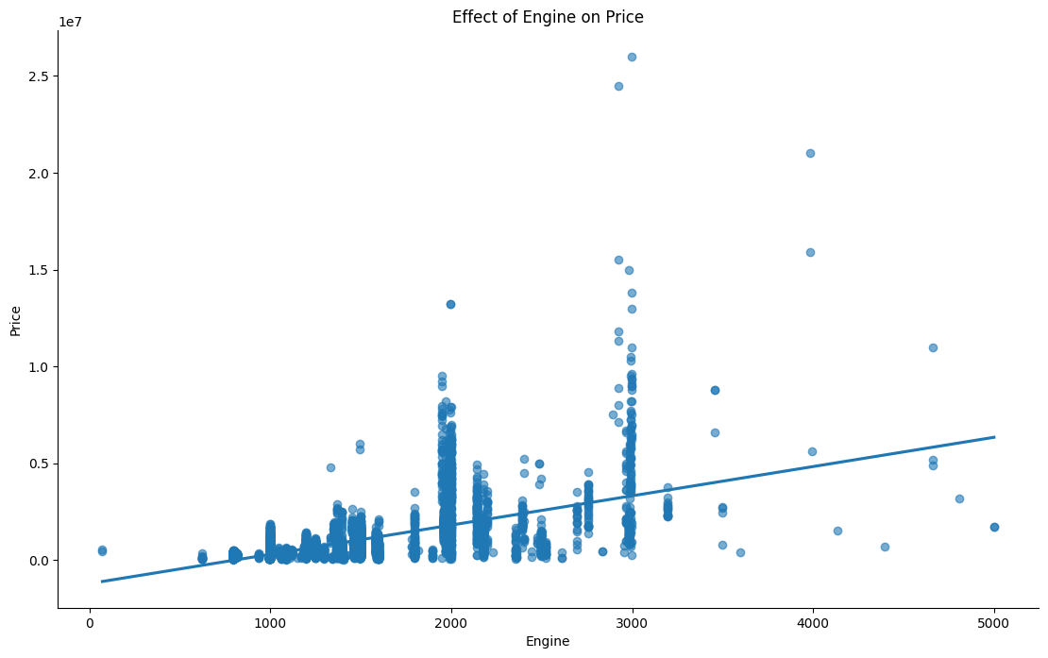

The price of the car increases if the Engine CC increases and we have the most number of cars in 700cc to 3000cc and we need to make sure the higher CC cars are present in highly valuable areas like bangalore ,chennai so we can make a little higher profit.

## 

## 

## Effect of Previous owner on Price

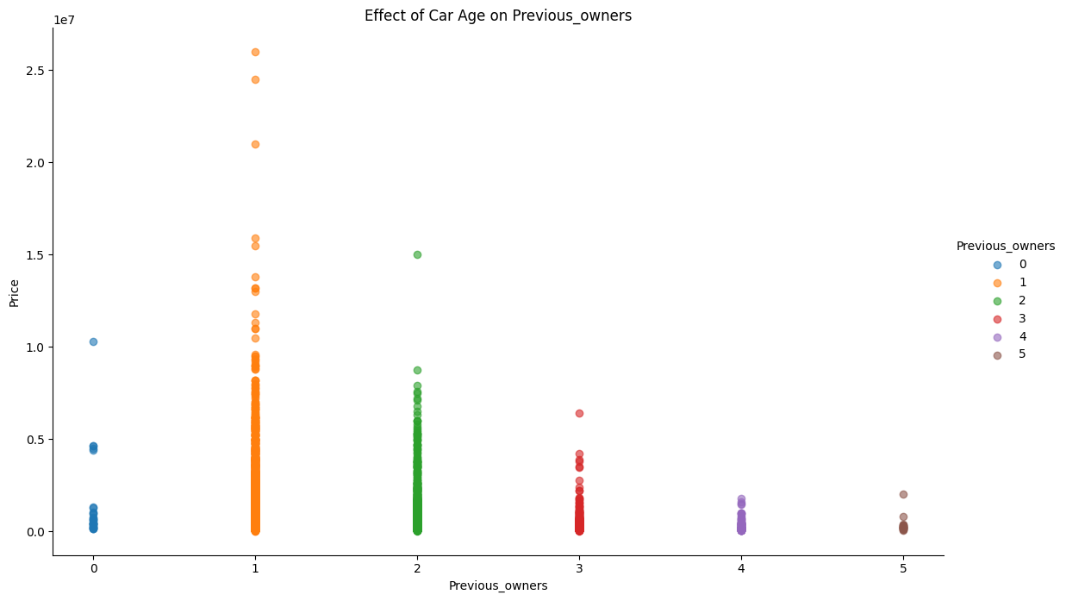

If the Car’s previous owner is 1 the price of the car is high and if 2 also the price is little higher when compared to other previous owners.

## 

## 

## Which body type cars we have the most

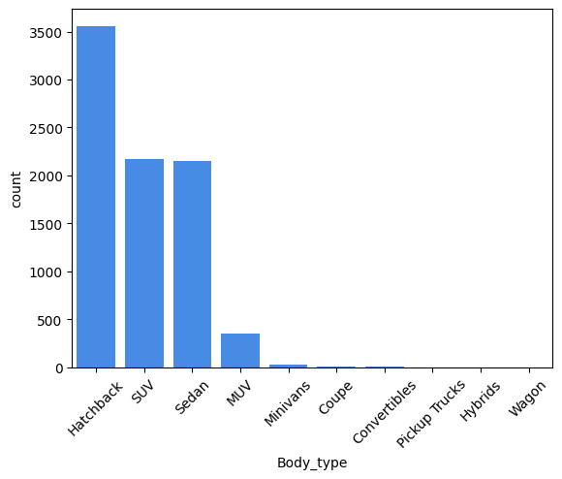

We have Hatchback,suv,sedan,MUV and minivans cars have the most when compare to other need to cross check whether these are have a market demand and need to take a decision based on that.

## What type of insurance validity we have the most

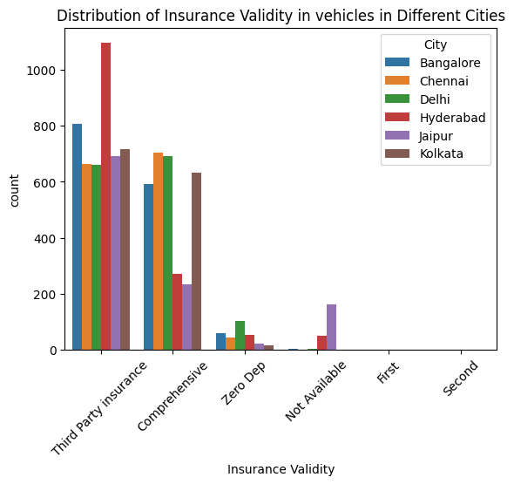

We don’t have a insurance in jaipur and Hyderabad cars need to filter out and apply insurance for those cars

# ML Model

For predicting the price of the cars based on the input given but the user we need to train our Machine learning model to predict the price accurately for achieving this we have used 7 different models and we got a 90% accuracy in one model so we used that for Deploying the App.

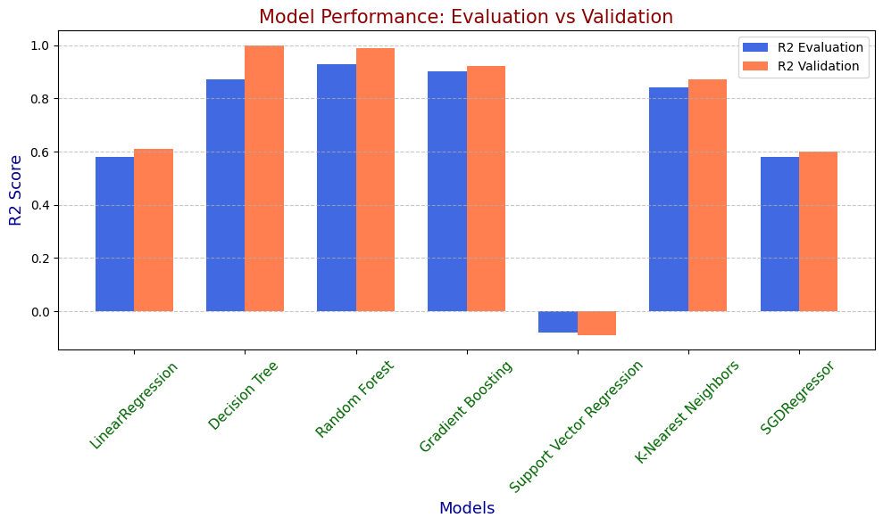

So we chose the Gradient Boosting model for app deployment.

# App Demo Video

[App Demo Video](https://drive.google.com/file/d/18lqdLMgsI8P849u_QFFAszmxBS07d9c1/view?usp=sharing)